Project Overview
This project expands on the CRUD Python module developed in Project One by creating an interactive dashboard for Grazioso Salvare using Dash and MongoDB. The dashboard allows users to browse animal shelter records, filter animals based on rescue training requirements, visualize breed distributions through charts, and display each selected animal’s location on an interactive map.
The application connects directly to the MongoDB AAC database using a custom Python CRUD module, providing real-time access to the shelter data through a user-friendly web interface.

Project Requirements
The dashboard includes the following functionality:
- Connected to the MongoDB AAC database using a custom CRUD Python module.
- Displayed all animal records in an interactive Dash DataTable.
- Allowed users to filter animals by rescue category:
  - Water Rescue
  - Mountain or Wilderness Rescue
  - Disaster or Individual Tracking
  - Reset (display all records)
- Displayed a pie chart showing the breed distribution of the filtered animals.
- Displayed an interactive map showing the selected animal’s geographic location.
- Included the Grazioso Salvare logo and a unique identifier.
- Supported table sorting, filtering, pagination, and row selection.

Technologies Used
- Python 3
- MongoDB
- PyMongo
- Pandas
- Dash
- JupyterDash
- Plotly Express
- Dash Leaflet
- Codio
- Jupyter Notebook

Files Included
- ProjectTwoDashboard.ipynb
- CRUD_Python_Module.py
- README.docx

Installation
- Start the MongoDB server.
- Open the project in Codio.
- Verify that the AAC database has been imported.
- Ensure the Grazioso Salvare logo image is located in the same directory as the notebook.
- Open ProjectTwoDashboard.ipynb.
- Run all notebook cells.
- The dashboard will launch within Jupyter Notebook.

Dashboard Features

Interactive Data Table
The dashboard initially displays all available shelter records. Users can:
- Sort records by column.
- Search and filter records.
- Select individual animals.
- Navigate through records using pagination.

Rescue Type Filters
Radio buttons allow users to display animals that meet Grazioso Salvare’s rescue requirements.
Available filters include:
- Reset
- Water Rescue
- Mountain or Wilderness Rescue
- Disaster or Individual Tracking
Each filter executes a MongoDB query through the CRUD module and refreshes the dashboard.

Breed Distribution Chart
The dashboard includes a dynamic pie chart that displays the distribution of animal breeds currently shown in the data table. The chart automatically updates whenever a different rescue filter is selected.

Interactive Map
Selecting an animal from the data table updates an interactive map that displays the selected animal’s geographic location. The map also displays the animal’s breed and name using Dash Leaflet markers and pop-up information.

CRUD Module
The CRUD_Python_Module.py file provides the database interface used by the dashboard application. The module establishes the connection to the MongoDB database and exposes Create, Read, Update, and Delete (CRUD) operations.

from pymongo import MongoClient
class AnimalShelter(object):
def __init__(self, username, password):
...
def create(self, data):
...
def read(self, query):
...
def update(self, query, update_data):
...
def delete(self, query):
...

### Method Descriptions

**create(data)**
- Inserts a new document into the MongoDB `animals` collection.
- Returns `True` if the insert succeeds; otherwise returns `False`.

**read(query)**
- Retrieves documents that match the supplied MongoDB query.
- Returns a cursor that is converted into a Pandas DataFrame by the dashboard.

**update(query, update_data)**
- Updates all documents matching the supplied query using the provided update values.
- Returns the number of documents modified.

**delete(query)**
- Deletes all documents matching the supplied query.
- Returns the number of documents removed.
Separating the database functionality from the dashboard improves maintainability, organization, and code reuse.

Challenges Encountered
One of the primary challenges during this project was integrating multiple Python libraries, including Dash, Plotly, Dash Leaflet, Pandas, and MongoDB, into a single application. Another challenge was ensuring that every dashboard component updated correctly whenever a rescue filter was selected. Careful testing of MongoDB queries and Dash callback functions ensured that the data table, chart, and interactive map remained synchronized. Additionally, MongoDB’s ObjectId field had to be removed before displaying data in the Dash DataTable to avoid compatibility issues.

Lessons Learned
This project strengthened my understanding of how backend databases interact with frontend dashboards. I gained experience writing MongoDB queries, developing interactive Dash applications, and creating callback functions that update multiple visual components simultaneously. I also reinforced the importance of separating database logic into a reusable CRUD module, making future development and maintenance significantly easier.

Future Improvements
Future enhancements could include:
- Additional data visualizations and charts.
- More advanced search capabilities.
- Dashboard summary statistics.
- Editing animal records directly from the dashboard.
- Improved dashboard styling using CSS.
- User authentication and role-based permissions.

Screenshots

Dashboard Home

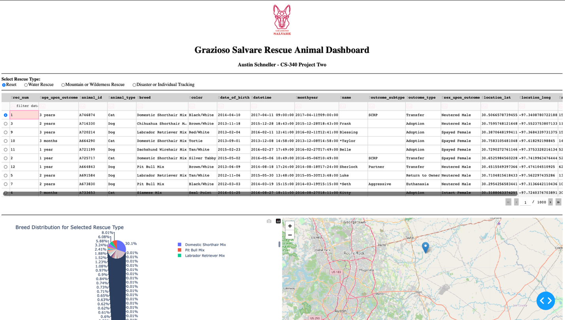

Water Rescue Filter

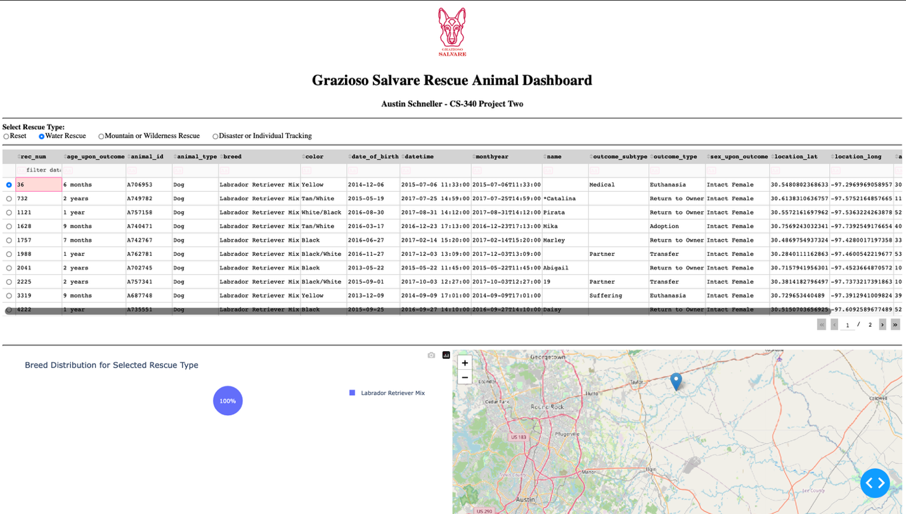

Mountain or Wilderness Rescue Filter

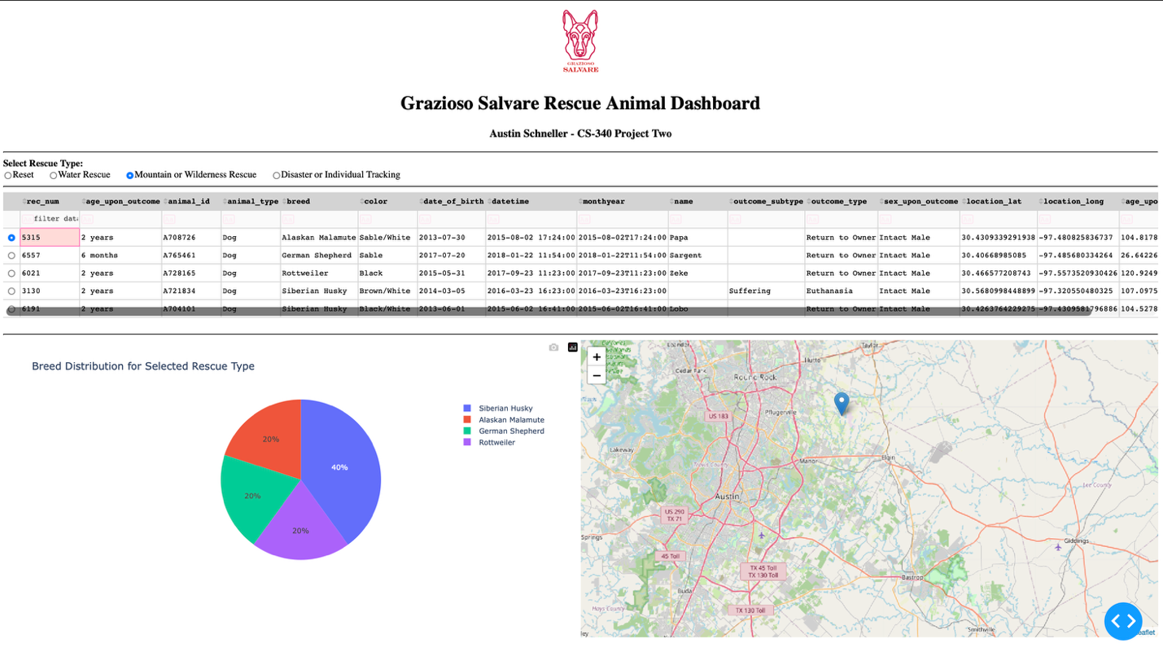

Disaster or Individual Tracking Filter

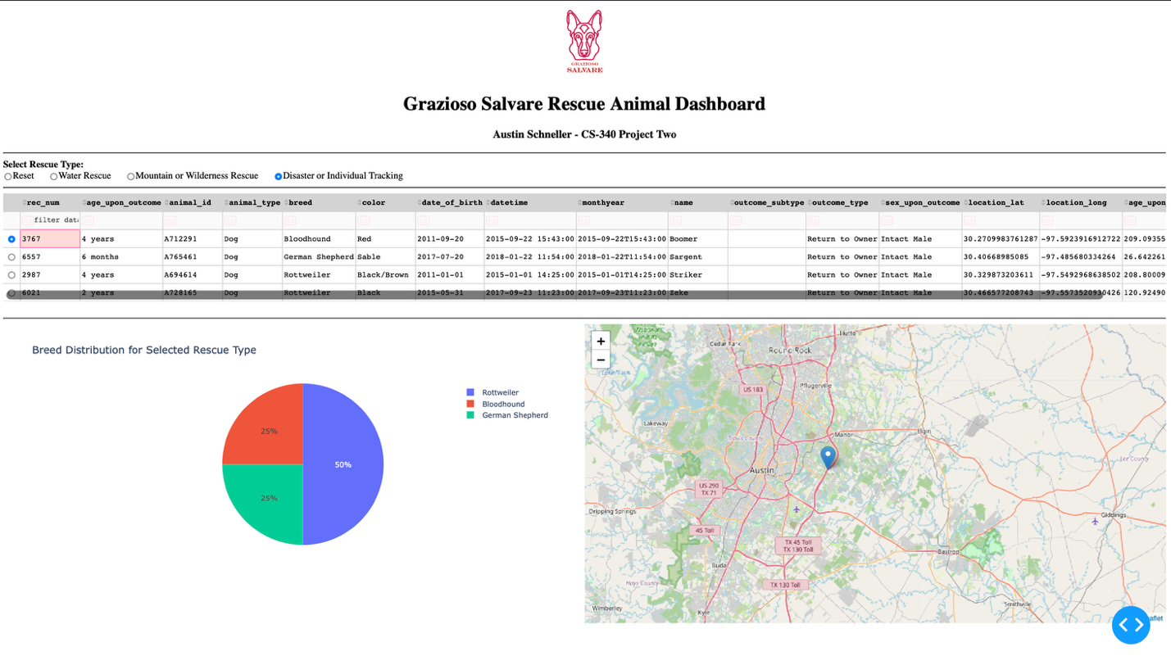

Interactive Map
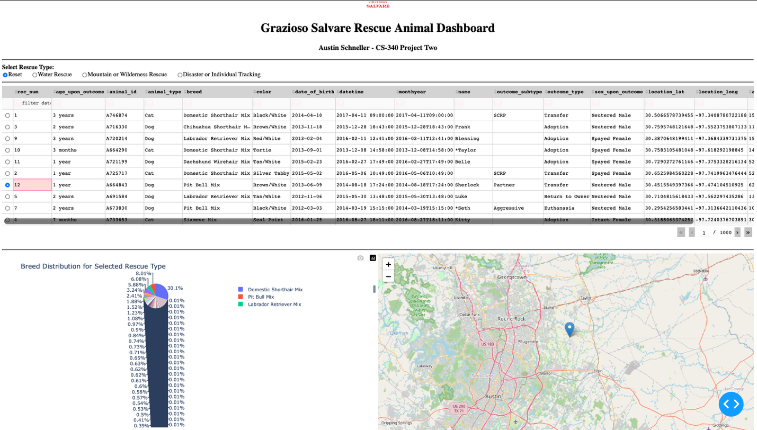.

Conclusion
This project successfully demonstrates the integration of a Python CRUD module, MongoDB database, and the Dash visualization framework to create an interactive dashboard for Grazioso Salvare. The completed application allows users to filter rescue candidates, visualize breed distributions, and locate individual animals using geographic data. The modular design makes the project easier to maintain and provides a strong foundation for future enhancements.

